

**EMAIL CLIENT SYSTEM**

Submitted by

**AISHWARYA ANN JOSEPH-2162044**

**AKHILA RESTINE THOMAS- 2162045**

**ALEENA MARY BENNY- 2162046**

**ALEENA SAJI-2162047**

**Excellence and Service**

**VISION**

To fortify Ethical Computational Excellence

**MISSION**

Imparts core and contemporary knowledge in the areas of Computation and Information Technology

Promotes the culture of research and facilitates higher studies

Acquaints the students with the latest  industrial practices, team building and entrepreneurship

Sensitizes the students to serve for environmental, social & ethical needs of society through lifelong learning.

**ABSTRACT**

The main aim of this code is to develop a code that describes the functional and non-functional requirements for an email client application.

The functional requirements include allowing the user to enter a valid email address for the recipient, a subject for the email, compose the email message, and send the email by clicking the "Send" button. The system should also verify that the email address is not empty or null, the subject is not empty or null, and that the email address is in the "@gmail.com" domain. Additionally, the system should display a success message and clear the fields after the email is sent successfully.

The non-functional requirements include having an intuitive and user-friendly interface, fast and responsive performance, well-documented and maintainable code, secure user data, and compatibility with various operating systems and devices.

The working description provides information on how the code achieves some of the functional requirements. It defines the EmailClient class, which implements the ActionListener interface and creates Swing components arranged into various panels using layout managers. The sendButton is assigned an ActionListener to handle clicks, and the actionPerformed method retrieves and validates the email address, subject, and message. The sendEmail method needs to be implemented to send the email using an SMTP server. Finally, the main method creates an instance of the EmailClient class and shows it to the user.

Overall, The email client application must allow the user to enter a valid email address, subject, and message and send the email successfully while verifying the data entered. It should also have an intuitive interface, fast performance, secure user data, and be compatible with different devices and operating systems.

**REQUIREMENT SPECIFICATION**

1. Functional Requirements:

* The user should be able to enter a valid email address for the recipient in the "To" field.
* The user should be able to enter a subject for the email in the "Subject" field.
* The user should be able to compose the email message in the text area.
* The user should be able to click the "Send" button to send the email.
* The system should verify that the email address is not empty or null before sending the email.
* The system should verify that the subject is not empty or null before sending the email.
* The system should verify that the email address is in the "@gmail.com" domain.
* The system should display a success message when the email is sent successfully.
* The system should clear the fields after the email is sent successfully.

1. Non-functional Requirements:

* The user interface should be intuitive and user-friendly.
* The application should have a fast and responsive performance.
* The code should be well-documented and maintainable.
* The application should be secure and prevent unauthorized access to user data.
* The application should be compatible with various operating systems and devices.

**WORKING DESCRIPTION**

The code defines a class called EmailClient which extends the JFrame class, meaning it is a window that can be displayed on the screen. The EmailClient class also implements the ActionListener interface, which allows it to handle button clicks.

Swing components like labels, text fields, and a text area are produced in the

EmailClient class' function Object() along with other Swing elements. Using various layout managers, these elements are arranged into various panels. The BorderLayout layout manager is then used to include these panels into the main container.

The sendButton is assigned an ActionListener to handle clicks using the addActionListener method. When the sendButton is clicked, the actionPerformed method is called, which retrieves the email address, subject, and message from the respective text fields. It then validates the data by ensuring that the email address is not empty, the subject is not empty, and that it has a valid email address ending in @gmail.com. If the data is valid, it calls the sendEmail method to send the email using the SMTP protocol.

The sendEmail method is a placeholder and is currently empty. It needs to be implemented with the actual logic to send the email using an SMTP server.

If there is an error in the data, an error message is displayed using the JOptionPane.showMessageDialog method. If the email is sent successfully, a success message is displayed to the user.Finally, the main method creates an instance of the EmailClient class and shows it to the user by calling the setVisible method.

**SNAPSHOTS**

Try exception 1:

When the email address of the sender is not available or cannot be located.

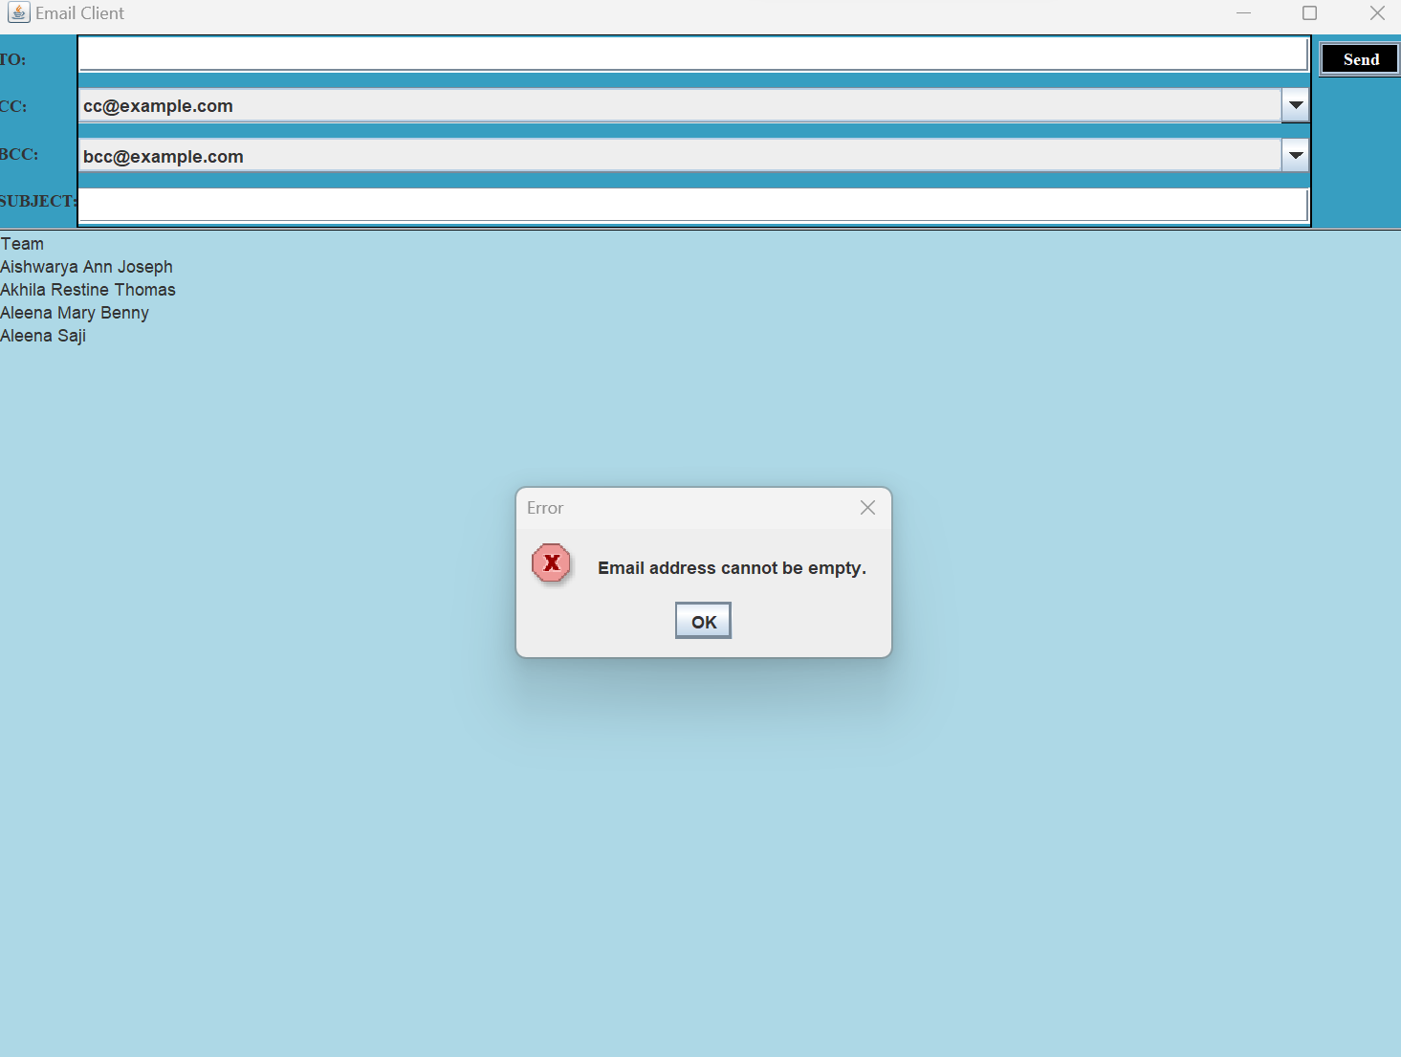

Try exception 2:

When the subject of the email is not specified by the sender.

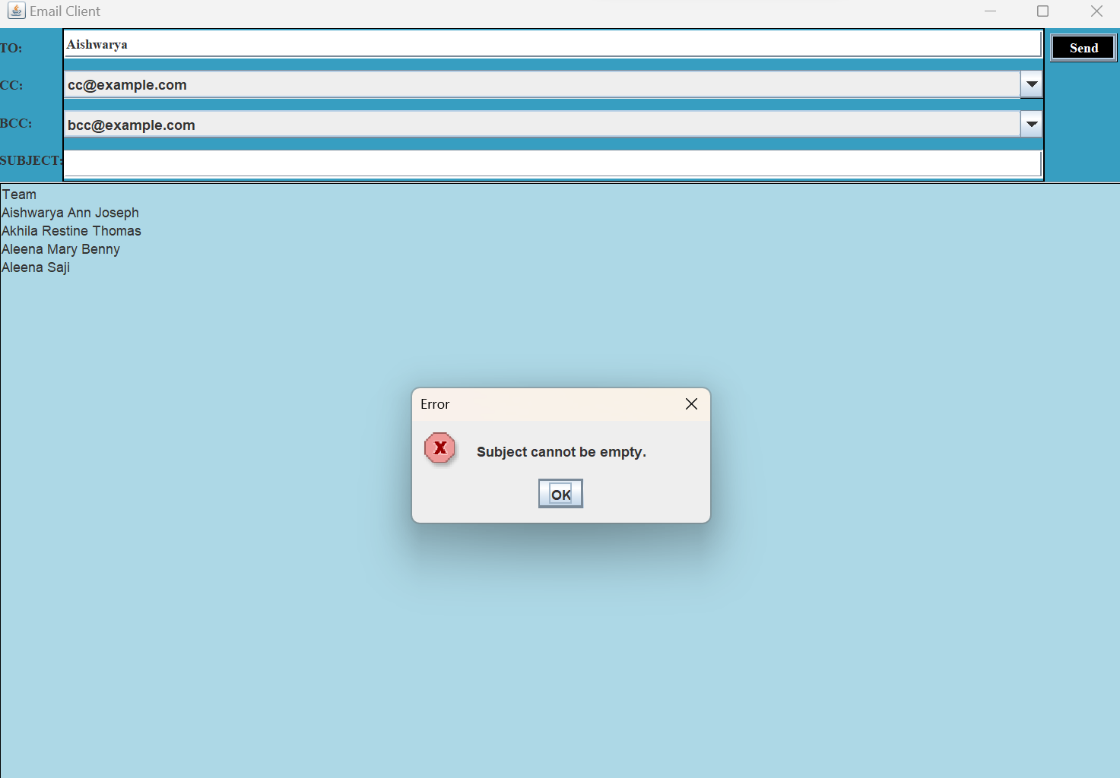

Try exception 3:

When the email address of the sender is not in the format of ending with the domain '@gmail.com’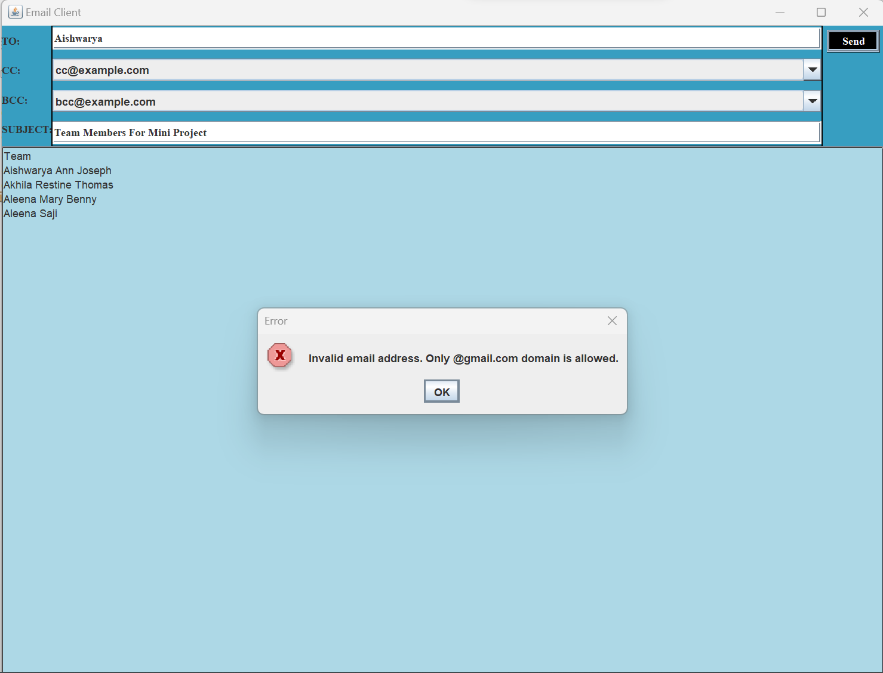

Final Output:

When the email is sent successfully to the intended recipient.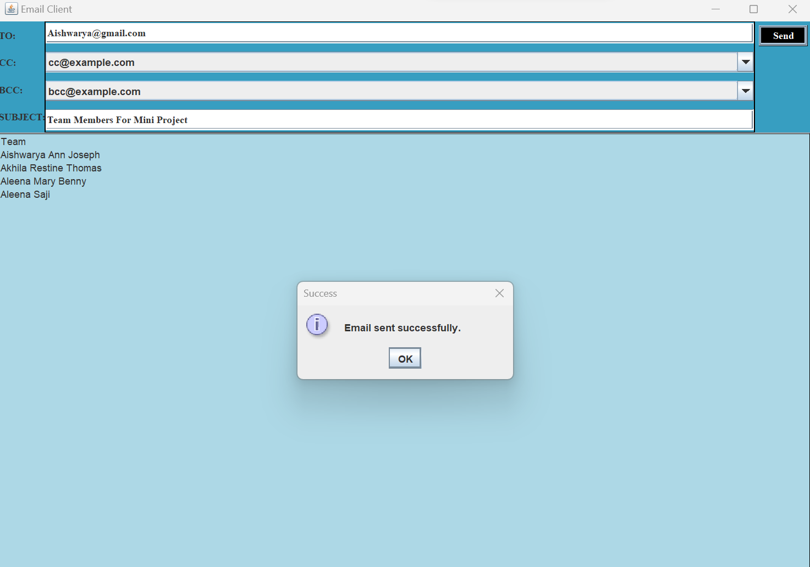

**CONCLUSION**

In conclusion, the EmailClient class is a simple graphical user interface (GUI) email client program that enables users to create and send emails. It showcases the usage of different Swing components such as text areas, text fields, and labels and demonstrates how to organize them using various layout managers. It also exhibits how to handle button clicks using the ActionListener interface and how to display success and error messages through. JOptionPane.showMessageDialog.

The EmailClient class is an easy-to-use email client program that allows users to create and send emails using a simple graphical user interface. It provides a basic set of features, including the ability to compose an email, specify a recipient and a subject, and view sent messages. Moreover, the application is written in Java, which makes it cross-platform compatible and capable of running on different

operating systems.

However, the program is restricted in its functionality as it only verifies the email address and subject and does not send the email. The sendEmail method must be implemented with the actual logic to send the email using an SMTP server. Furthermore, the application only accepts email addresses with a @gmail.com domain, which reduces its versatility.

In general, the EmailClient class serves as a starting point for developing a more comprehensive email client application with extra features such as attachment support, inbox and outbox management, and support for multiple email providers.

**REFERENCES ( Papers/ Books/ Websites etc)**

1. Javapoint
2. JavaApplication Text Book
3. Javaswing Reference Sheet
4. GeeksforGeeks
5. Tutorialspoint
6. Stackoverflow
7. Coderanch